INDIVIDUAL FINAL INFORMATION FORM

FOR

COMPETITOR TEAM MANAGER JURY MEMBER JUDGE

Passport photograph
to paste here

Photograph of model
to paste here
for competitors only

Address: Wloclawek Aero Club 87-853 Kruszyn Poland
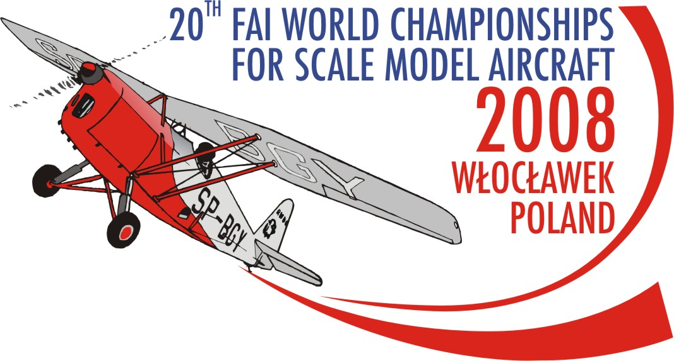
Tel: +48 54 253 54 43
Fax: +48 54 253 54 43
Official F4 WCh 2008 e-mail: scalemodel2008wch@w3wl.pl
Official F4 WCh 2008 webside www.scalemodel2008wch.w3wl.pl
Contact person Anna Pakulska
Mobile: +48 667 673 479

Last Name: ……………………………….….….
First name: ……….……………………….….….
Country: ……………………..………….…….
e-mail: ……………………….…….…....
Age: ………
Years in aeromodelling: ………

Years in F4 B or F4C class: …………..………
Your aeromodelling:

………………………………………………………………………………………………………………………………………………..…..……….….

………………………………………………………………………………………………………………………………………….………………….….

………………………………………………………………………………………………………………………………………….……………………..

…………………………………………………………………………………………………………………………….…………………………………..

Achievements in F4B or /and F4C class /nationals, World/Continental Championships, World Air Games/:

……………………………………………………………………………………………………………………………..………………………………….

………………………………………………………………………………………………………………………….……………………………………..

……………………………………………………………………………………………………………………….………………………………………..

Another interests and hobbies:

………………………………………………………………………………………………………………………….……………………………………..

……………………………………………………………………………………………………………………….……………………………………….
Positions in the aeromodelling organizations:

……………………………………………………………………………………………………………………………..……………………..………….

……………………………………………………………………………………………………………………………..……………………..………….

……………………………………………………………………………………………………………………………..……………………..………….

……………………………………………………………………………………………………………………………..……………………..………….

………………………………………………………………………………………………………………………….…………………………………….

To be filled-in by the competitor only
/minimum one reserve frequency is required/

FREQUENCY | MHz | CHANNEL  NUMBER
BASIC | _ _,_ _ _
Reserve 1 | _ _ , _ _ _
Reserve 2 | _ _ , _ _ _

Name of model prototype: ………….…………
……………………..………………..………….…
Year of prototype manufacture: ……………….
Scale of model: ……………………..……..…..
Model wing span: ………………………....…

Weight of model [kg]: ……………..…………..
Model Surface area [dm2]: …………….…….
Model engine type & manufacturer:
..............................................…………………..
Remote equipment type & manufacturer:
…………..………………………………..……….

………………………………………………. ……………………………………
Place and date signature

