
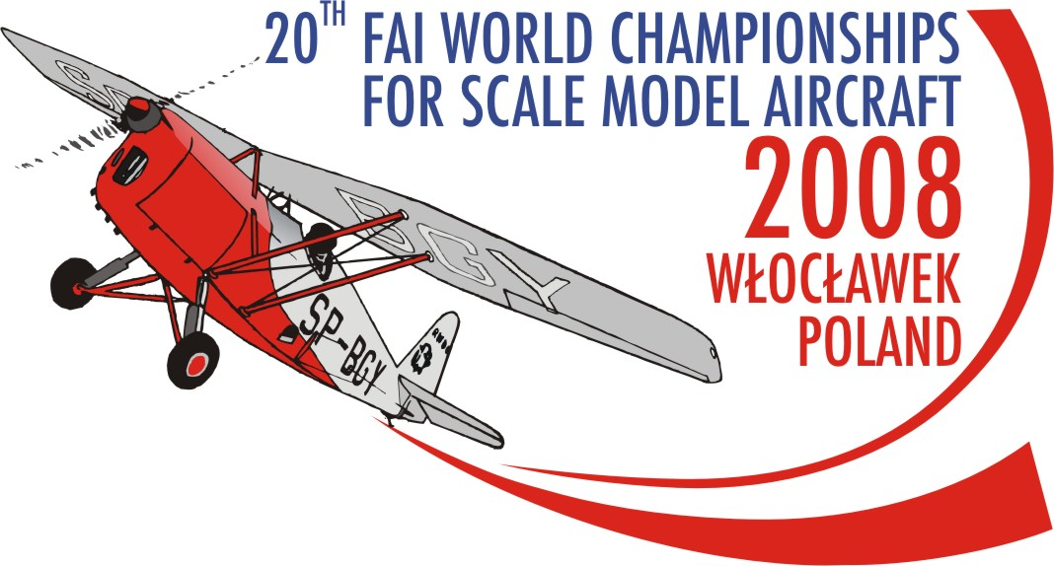

FINAL ENTRY FORM

FOR SCALE MODEL AIRCRAFT NATIONAL TEAM
F4B sen., F4B jun., F4C CLASS

The National Airsports Controlled …………………………………………………………………………………………………….……………............
enters for THe 20th FAI world Championships for Scale Model aircraft the team consisting of:

 |  |  |  |  |  | Date OF |  | Accommodation |  |  |  |  | Meals |  |  |  |  | ENTRY Fees
CLASS | TEAM | Last NAME | FIRST NAME | Sex | FAI LICENCE  number | Arrival | Departure | QTY of days | Room price | HOTEL TOTAL  I x J | CAMPING | CAMPING TOTAL  I x L | Lunch | Dinner | Amount  (N + O) x I | Tour | Banquet | ENRTY fee  TM, ATM, COMP. | ENRTY fee  H, S | TOTAL  k+M+p+r+s+t+U
 |  | With BLOCK letters |  | M/F |  |  |  |  | [€] | [€] | [€] | [€] | [€] | [€] | [€] | [€] | [€] | [€] | [€] | [€]
A | B | c | d | e | f | g | h | i | j | K | L | m | n | o | p | r | s | t | u | W
F4B SEN.  F4C | TM
F4B SEN.  F4C | TMA
F4B SEN. | 2006 wch cHAMPION
F4B SEN. | Competitor
F4B SEN. | Competitor
F4B SEN. | Competitor
F4B SEN. | Helper
F4B SEN. | Supporter
F4C | 2006 wch cHAMPION
F4C | Competitor
F4C | Competitor
F4C | Competitor
F4C | Helper
F4C | Supporter
F4B JUN | TM
F4B JUN | TMA
F4B JUN. | Competitor
F4B JUN. | Competitor
F4B JUN. | Competitor
F4B JUN. | Helper
F4B JUN. | Supporter
F4B JUN. | Supporter
 |  |  |  |  |  |  |  |  |  |  |  |  | TOTAL FEE TO BE REMITTED:

Date and time of arrival to WLocLawek: …………………………….................................

tHE Entry form must be sent to the address /no later than 15-04-2008/:

AEROCLUB OF WLOCLAWEK

Kruszyn Airfield
87-853 Kruszyn
POLAND
mobile: +48 667 673 479 Anna Pakulska

tel.: +48 54 235 54 43

Fax: +48 54 235 54 43
e-mail: scalemodel2008wch@w3wl.pl
web side: www.scalemodel2008wch.w3wl.pl

The full fee must be remitted till 15-05-2007 to the following bank account with the title: fai f4b, c WCH2008

Bank Name: Bank Millennium SA

Bank Address: Al. Jerozolimskie 123A 02-017 WARSZAWA

IBAN: PL94 1160 2202 0000 0000 8330 1354

A/C No.: 94 1160 2202 0000 0000 8330 1354

BIG: BIGBPLPWXXX

Swift Code: BIGBPLPWXXX

………………………………………………. ……………………………………
Place and date signature of official & stamp of NAC

