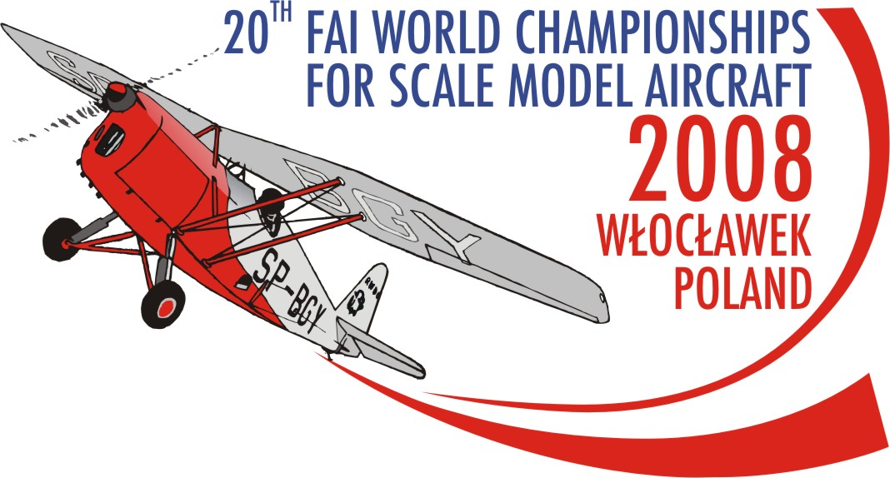

FAI 20th WORLD CHAMPIONSHIPS
FOR FLYING SCALE MODEL AIRCRAFT
WLOCLAWEK 2008 POLAND

PRELIMINARY ENTRY FORM
FOR NATIONAL TEAM

The National Airsports Control of ……………………………………………..........................................................................

enters for THe 20th FAI world Championships for Scale Model aircraft 2008 wloclawek the NATIONAL team consisting of:
- TEAM MANAGER: .................
- TEAM MANAGER ASSISTANT: .................
- F4B COMPETITORS SENIORS: .................
- F4C COMPETITORS: .................
- TEAM MANAGER FOR F4B JUNIOR: .................
- TEAM MANAGER ASSISTANT FOR F4B JUNIOR: .................
- F4B COMPETITORS JUNIORS: .................
- HELPERS AND SUPPORTERS: .................
TOTAL NUMBER OF PARTICIPANTS: .................

nATIONAL aERO cLUB: ......................................................................................................................................

cONTACT PERSON: ......................................................................................................................................

cONTACT PHONE: .......................................................................................................................................

cONTACT E-MAIL: .......................................................................................................................................

cONTACT POSTAL ADDRESS: .......................................................................................................................................

.......................................................................................................................................

.......................................................................................................................................
Please do note:
- the entry form must be typed or written with BLOCK letters.
2. tHE PRELIMINARY Entry form must be sent to the ORGANIZER’S address no later than 15-02-2008:

ORGANIZER’S address:

AEROCLUB OF WLOCLAWEK

Kruszyn Airfield
87-853 Kruszyn
POLAND
mobile: +48 667 673 479 Contact Person: Anna Pakulska

tel.: +48 54 235 54 43

Fax: +48 54 235 54 43
e-mail: scalemodel2008wch@w3wl.pl
web side: www.scalemodel2008wch.w3wl.pl

…………………… …………………………………………………………
Place and date signature of mac official & stamp of NAC

