Appendix no.1

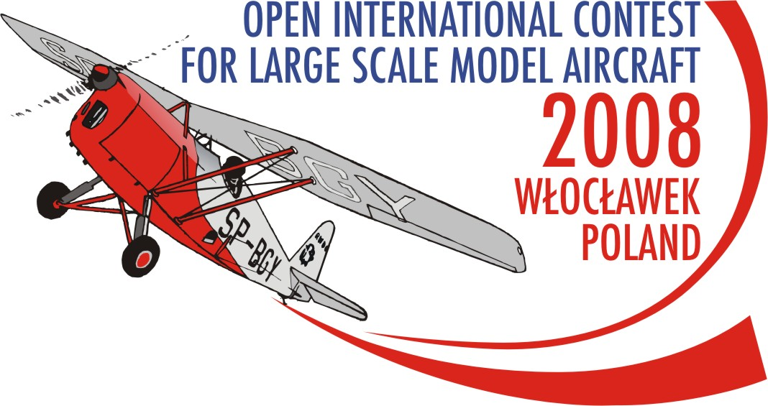

FINAL ENTRY FORM

FOR COMPETITOR
F4G CLASS LARGE SCALE AIRCRAFT

I enter for THe FLYING LARGE SCALE Model aircraft OPEN INTERNATIONAL CONTEST 2008 wloclawek poland
 |  |  |  |  |  | Date OF |  | Accommodation |  |  |  |  | Meals |  |  |  |  | ENTRY Fees
CLUB  COUNTRY | PERSON | Last NAME | FIRST NAME | Sex | FAI LICENCE  number | Arrival | Departure | QTY of days | Room price | HOTEL TOTAL  I x J | CAMPING | CAMPING TOTAL  I x L | Lunch | Dinner | Amount  (N + O) x I | Tour | Banquet | ENRTY fee  TM, ATM, COMP. | ENRTY fee  H, S | TOTAL  k+M+p+r+s+t+U
 |  | With BLOCK letters |  | M/F |  |  |  |  | [€] | [€] | [€] | [€] | [€] | [€] | [€] | [€] | [€] | [€] | [€] | [€]
A | B | c | d | e | f | g | h | i | j | K | L | m | n | o | p | r | s | t | u | W
 | Competitor
 | Helper
 | Supporter
 |  |  |  |  |  |  |  |  |  |  |  |  | TOTAL FEE TO BE REMITTED:

Date and time of arrival to WLocLawek: …………………………….

tHE Entry form must be sent to the address /no later than 30-05-2008:/

AEROCLUB OF WLOCLAWEK

Kruszyn Airfield
87-853 Kruszyn
POLAND
mobile: +48 667 673 479 Anna Pakulska

tel.: +48 54 235 54 43

Fax: +48 54 235 54 43
e-mail: scalemodel2008wch@w3wl.pl
web side: www.scalemodel2008wch.w3wl.pl

The full fee must be remitted till 15-05-2007 to the following bank account with the title: fai f4b, c WCH2008

Bank Name: Bank Millennium SA

Bank Address: Al. Jerozolimskie 123A 02-017 WARSZAWA

IBAN: PL94 1160 2202 0000 0000 8330 1354

A/C No.: 94 1160 2202 0000 0000 8330 1354

BIG: BIGBPLPWXXX

Swift Code: BIGBPLPWXXX

………………………. ………………………..……..…… ………………….…….
Place and date NAME OF COMPETTITOR signature of COMPETITOR

