INDIVIDUAL INFORMATION FORM FOR

COMPETITOR TEAM MANAGER JURY MEMBER JUDGE

Passport photograph
to paste here

Photograph with model
to paste here
for competitors only

Event Director: Marek Kozinski
Address: Wloclawek Aero Club 87-853 Kruszyn Poland
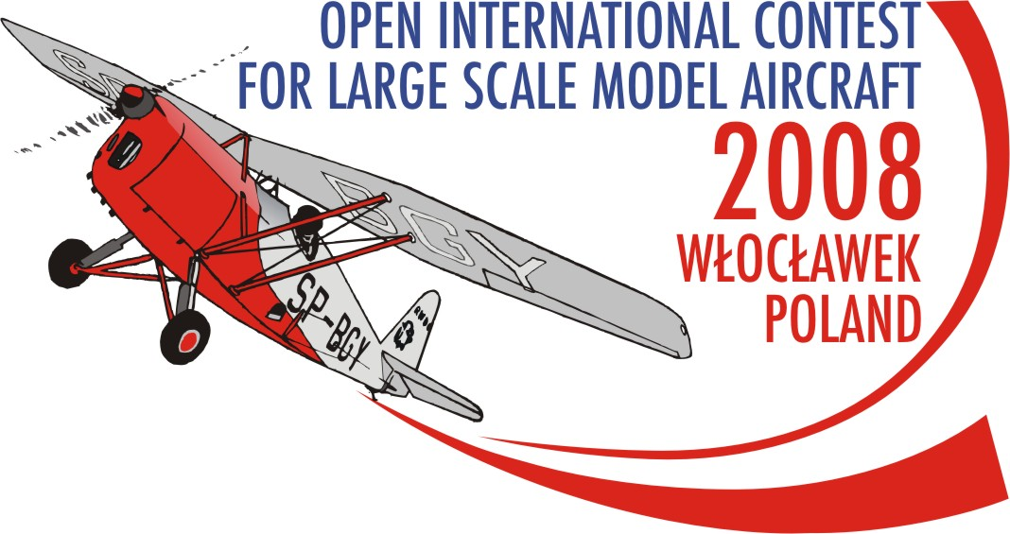
Tel: +48 54 253 54 43
Fax: +48 54 253 54 43
Official F4 WCh 2008 e-mail: scalemodel2008wch@w3wl.pl
Official F4 WCh 2008 webside www.scalemodel2008wch.w3wl.pl
Contact person Anna Pakulska
Mobile: +48 667 673 479
Languages: English, Polish

Last Name: ……………………………….….….
First name: ……….……………………….….….
Country: ……………………..………….…….
Your e-mail: ……………………….…….…....
Age: ………
Years in the aeromodelling: ………

Years in F4 G class; …………..………
Your start with aeromodelling:

………………………………………………………………………………………………………………………………………………..…..……….….

………………………………………………………………………………………………………………………………………….………………….….

………………………………………………………………………………………………………………………………………….……………………..

…………………………………………………………………………………………………………………………….…………………………………..

Your achievements in F4G class /nationals, …./:

……………………………………………………………………………………………………………………………..………………………………….

………………………………………………………………………………………………………………………….……………………………………..

……………………………………………………………………………………………………………………….………………………………………..

Your another interests and hobbies:

………………………………………………………………………………………………………………………….……………………………………..

……………………………………………………………………………………………………………………….……………………………………….
Your positions in the aeromodelling organizations:

……………………………………………………………………………………………………………………………..……………………..………….

……………………………………………………………………………………………………………………………..……………………..………….

……………………………………………………………………………………………………………………………..……………………..………….

……………………………………………………………………………………………………………………………..……………………..………….

………………………………………………………………………………………………………………………….…………………………………….

To be filled-in by the competitor only
/minimum two frequencies are required/

FREQUENCY | MHz | CHANNEL  NUMBER
BASIC | _ _,_ _ _
Reserve 1 | _ _ , _ _ _
Reserve 2 | _ _ , _ _ _
Reserve 3 | _ _ , _ _ _

Model name of prototype: ………….…………
……………………..………………..………….…
Year of prototype manufacture: ……………….
Scale of model: ……………………..……..…..
Model engine manufacturer: …………………..
Model wing span: ………………………....…
Weight of model [kg]: ……………..…………..
Model Surface area [dm2]: …………….…….
Remote equipment manufacturer: …………..
…………..……………………………………….

