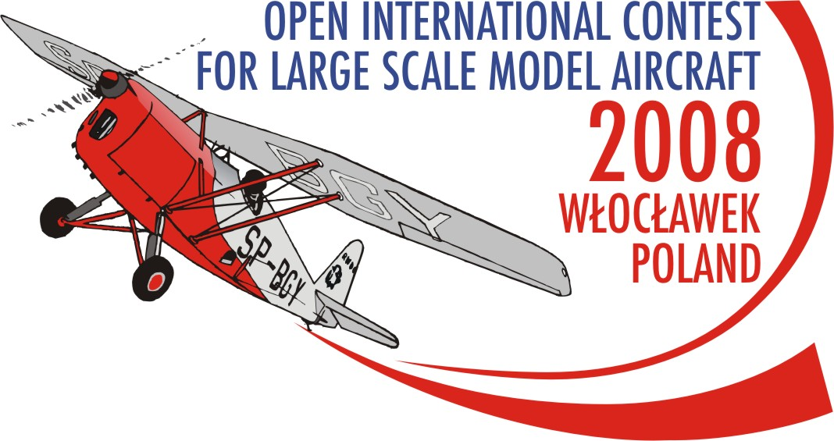

OPEN INTERNATIONAL CONTEST
FOR LARGE SCALE MODEL AIRCRAFT
WLOCLAWEK 2008 POLAND

PRELIMINARY ENTRY FORM
FOR INDIVIDUAL COMPETITOR

……………………………………………………………….. enterS for THe OPEN INTERNATIONAL CONTEST for LARGE Scale Model aircraft 2008 wloclawek POLAND AS A COMPETITOR.

THE “Team” consistS of:
- F4G COMPETITOR: 1
- HELPERS AND SUPPORTERS: .................
TOTAL NUMBER OF PARTICIPANTS: ..................

lAST NAME OF COMPETITOR ......................................................................................................................................

FIRST NAME OF COMPETITOR ......................................................................................................................................

cONTACT PHONE: .......................................................................................................................................

cONTACT E-MAIL: .......................................................................................................................................

AERO cLUB: ......................................................................................................................................

cONTACT POSTAL ADDRESS: .......................................................................................................................................

.......................................................................................................................................

.......................................................................................................................................
Please do note:
- the entry form must be typed or written with BLOCK letters.
2. tHE PRELIMINARY Entry form must be sent to the ORGANIZER’S address no later than 15-04-2008

ORGANIZER’S ADDRESS:=

AEROCLUB OF WLOCLAWEK

Kruszyn Airfield
87-853 Kruszyn
POLAND
mobile: +48 667 673 479 Contact Person: Anna Pakulska

tel.: +48 54 235 54 43

Fax: +48 54 235 54 43
e-mail: scalemodel2008wch@w3wl.pl
web side: www.scalemodel2008wch.w3wl.pl

…………………… …………………………………………………………
Place and date signature of COMPETITOR

